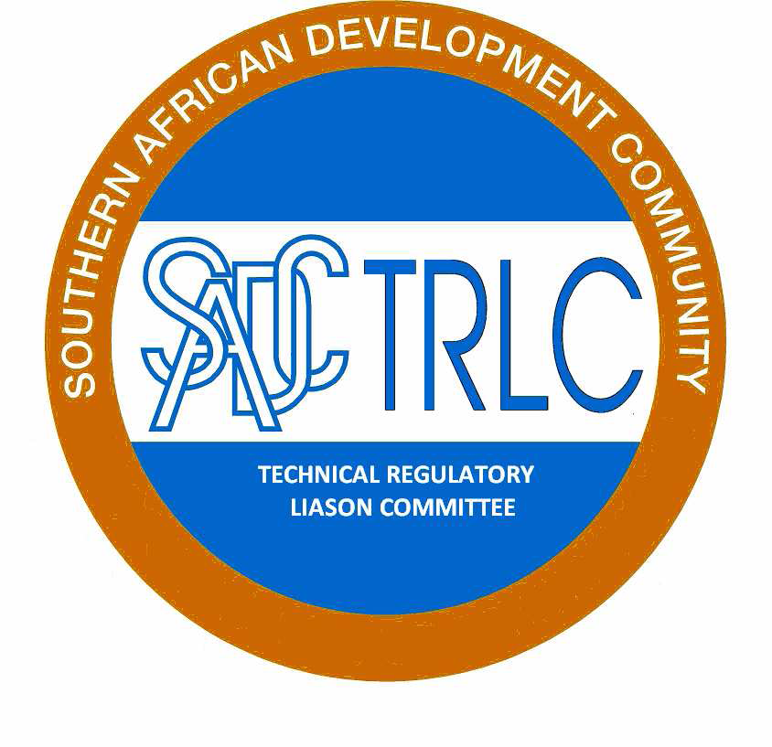



**Draft Minutes**

**SADCTRLC Annual General Meeting (AGM)**

**Date: 17 March 2016**

**Venue: Gaborone, Botswana Phakalane Estate Golf Hotel**

**ATTENDEES**

The following Member States (MSs) and representative from other SADCTBT Structures attended the above-mentioned meeting (attendance register attached):

***MSs:***

Angola, Botswana, Democratic Republic of Congo, Malawi, Mauritius, Mozambique, Namibia, Swaziland, South Africa, Seychelles, Zambia, and Zimbabwe; and

***SADCTBTEG Structures:***

SADCTBTSC

SADCSTAN

SADCMEL

SADCMET

**INTRODUCTION**

The Chairperson, Mr Johannes Mosanawe from Botswana opened the meeting and welcomed everyone present.

The meeting recorded a quorum with eleven (11) MSs attending and noted an apology from Lesotho. A representative from Mauritius joined the meeting later.

The meeting adopted the agenda (attached) as proposed by the SADCTRLC Secretariat.

The meeting considered matters arising from the SADCTRLC Resolutions 2015/16 that were agreed to during the 2015 meeting in the DRC.

**MATTERS ARISING FROM THE RESOLUTIONS 2014/15**

The meeting considered and reflected on the resolutions that were not part of the agenda items of the meeting. The resolutions are resolution 4, 6, 9, 13, 13, and 17.

**MEETING DISCUSSION**

The meeting discussed various matters as per the attached agenda. The discussions and conclusions were as follows:

**Five (5) Strategic Year Plan (Plan):** The SADCTRLC Regional Coordinator (RC) gave a presentation with respect to the Plan by indicating that the draft plan is in place however there is still an outstanding work that is to be considered by the planned April 2016 meeting. The plan will, amongst other things, include the roll-out and implementation of the Risk and Impact Assessment, GHS implementation, Harmonization of TRs, Alert System, Methodology to develop position to the WTO and Alignment with the Industrial Development Policy.

Action: MSs are requested to submit proposals for consideration at the EWG meeting that is planned to take place during the month of April 2016. The proposals to be submitted by the 7th April 2016 (Resolution 1 of 2016).

**Baseline Study on Technical Regulations (TRs):** The SADCTRLC Secretariat provided the meeting with the presentation in this regard. The presentation confirmed that the study is finalized and requires that it is validated by MSs who participated in the survey. The validation period is set to take two months.

Also, that the base line study proposes 24 TRs for harmonization. The SADCTRLC EXCO considered that the study prioritizes five (5) TRs for harmonization.

The five (5) TRs are as follows:

1. **Botswana:** Standard Import Inspection Regulation.
2. **Botswana:** Pre-packaged labeling regulations.
3. **Mauritius:** Consumer Protection (Control of Imports) Regulations 1999, GN No. 135 of 1999, Electric Cable insulated with plastic materials, Armoured Electric Cables, Residual current operated circuit-breakers for household and similar uses, MS 17, MS 101 and MS 113. (South Africa will take the lead on this and choose one product).
4. **Swaziland:** Biosafety Regulation 2013 Agriculture.
5. **Zambia:** ZS 371 Regulations (all foreign trucks required to comply with it).

The first meeting for this work is scheduled to take place during April 2016.

The presentation indicated the model that will be used to harmonize TRs in the SADC Region. The harmonization of five TRs is to test the model proposed to harmonize TRs in the SADC Region.

The meeting debated the model to harmonize TRs in the region and resolve to endorsed the model and encourage that procedure to harmonize TRs is developed. Also that SADC secretariat will assist to implement the harmonized TR/s via the Council of Ministers of Trade and MSs.

The meeting concluded that the Model should be implemented and that standards that require harmonization as a result of this work be referred to SADCSTAN.

It was also proposed that SADCTRLC develop procedures to be used for harmonisation of TRs (Resolution 4 of 2016)

Action: Participating MS are expected to validate the report before the end of May 2016. (Resolution 3 of 2016).

**Regulatory Impact Assessment (RIA) Progress Report**: The RC gave presentation in this regard by indicating that the project is underway and have trained ten (10) MSs, namely Angola, Botswana, Lesotho, Malawi, Mozambique, Namibia, Swaziland, South Africa, Zambia, and Zimbabwe. The RC informed the meeting that Mauritius did not participate in the RIA training as they have participated in the RIA under another EU training programme. The meeting considered that there are other MSs, such as Seychelles, Democratic Republic of Congo, Tanzania and Madagascar, that did not participate in the training, however acknowledge there is a plan to extend the training via the REIS programme. The meeting concluded the following in this regard:

* Common slides will be developed by SADCTRLC Exco to assist those that were trained to replicate the training in their Member States in a uniform way.
* Issues that were raised during the evaluation of the training will be incorporated into the common slides, such as Risk and Impact Assessment versus Regulatory Impact Assessment; RIA and Good Regulatory Practice etc.
* PTB is willing to support Member States with some of the logistical costs for the National roll-out.
* Member States will be expected to report on progress, bi-annually as part of their country reports. (Resolution 5 of 2016)

**SADCTRLC Website:** The SADCTRLC Secretariat indicated that the SADCTRLC website is functional and MSs are encouraged to use the website from now on. The approach is that SADCTRLC will upload all communications to the SADCTRLC website however indicate, via the email, that there is new information posted on the SADCTRLC Website. Log-ins for PTB and SADC Secretariat is also being provided (Resolution 6 of 2016).

**GHS Project Progress Report:** The SADCTRLC Secretariat provided the meeting the presentation with respect to GHS Project indicating that the GHS survey questionnaire was sent to all 15 MSs. Six (6) MSs participated in the GHS survey, namely Botswana, Madagascar, Namibia, South Africa, Swaziland, and Zambia. The survey results demonstrate that five MSs require 240 copies of the GHS policy document and training for 186 participants. The presentation indicated that PTB requires that MSs to fill-in the PTB request form for assistance. The SADCTRLC AGM debated the project and resolute that MSs that did not participate in the survey are encouraged to fill-in the questionnaire for need/s assessment accompanied by the PTB request form.

* **Action:** MSs that did not participate are all also requested to submit their proposals, including the PTB request form, to the SADCTRLC secretariat by the 7th April 2016 (Resolution 7 of 2016).

**MSs Report Submission:** SADCTRLC noted and thanked the 8 MSs that have submitted their member state reports. The SADCTRLC Secretariat will verify the contact list with assistance from the SADC Secretariat by writing letters to the Permanent Secretaries of MSs and also request them to nominate alternates to the SADCTRLC. (Resolution 8of 2016 and 9).

**Alert System Project:** SADCTRLC Secretariat gave a presentation with respect to the Alert System indicating its rationale. The Alert System is aimed to serve as a communication channel to all MSs for products that are no compliant to the Technical Regulations of a specific MS. The website will incorporate the interactive page that will allow MSs to communicate non-compliant products in the SADC region. SADCTRLC approached PTB to expand the scope of the SADCTRLC website via the NMISA assistance. The initial thinking was to do the project under the supervision of the Sida-Swedac programmes. However, Swedac did not approve of this project as it was of the opinion that the lack of harmonised, Technical Regulations in SADC will make this a difficult exercise. The SADCTRLC Exco debated the matter and concluded that the project to continue using the SADCTRLC Website. The SADCTLC AGM debated and concurred that the project to be continued under the SADCTRLC Website. Legal issues should also be explored when the ToR is developed. PTB agreed to support the project. (Resolution 10 of 2016).

**Used Motor Vehicle Project:** The SADCTRLC AGM meeting noted the presentation on the progress made with respect to the Second Hand Tyre Project, Resolution 11. The meeting agreed that the outstanding work to be finalized during the month of April 2016. The meeting noted that only one MSs commented on the concept paper and encouraged that all MSs to comment on the paper. The meeting noted the difficult associated with this project as MSs are at different level in as far as the second hand car is concerned. The meeting indicated that some MSs are having Primary Laws in as far as the second hand cars are concerned, while other MSs are having Secondary Laws and/or Standards for second hand cars.

* **Action:** MSs are encouraged to provide inputs by 7 April 2016 (Resolution 11 of 2016).**SADCTRLC MSs Reports (All):** All 8 MSs that submitted reports presented their reports and there were no comments on the reports. The meeting agreed that MSs shall submit MSs Country reports one month before the SADCTRLC AGM. This will allow the SADCTRLC Secretariat enough time to combine all reports into one SADCTRLC Annual report.

**SADC Secretariat Report:** SADC Secretariat Report by Ms Kuena Molapo outlined that the REIS Funding programme is coming to an end and encourage MSs to use the funding before the end of June 2016. SADCTRLC Secretariat introduced new employees that will work for SADC as one (1) Senior Programme Officer, Dr Lomkhosi Mkhonto, and two (2) TBT/SPS Expert, Dr Geoff Visser. The new employees are replacing Dr Elsie Meintjies and Dr Oswald Chinyamakobvu, respectively.

**PTB Report:** Mr Martin Kaiser from PTB reported that a presentation will be given at TBTEG on the 18 March 2016.

**Election of office Bearers:** SADCTRLC AGM considered that the term of office for both SADCTRLC EXCO and Secretariat will come to an end in March 2016. Member States were therefore requested to obtain support from their respective principals to stand for elections.

The meeting was informed that no nominations were received from MSs, but that the current EXCO was eligible for re-election and that all of the EXCO members confirmed their respective availability. The meeting was further informed that the Chairperson indicated that he will be retiring and therefore Botswana will step down as Chairperson but remain as a member of EXCO. Swaziland indicated that it was willing to take the position of the Chairperson.

The SADCTRLC AGM considered the proposal and proposed that the current office to continue with the office in accordance with the rules of procedures. The meeting elected Swaziland as the new Chairperson. The Vice Chairperson is Zambia and Secretariat is South Africa. (Resolution 12 of 2016).

**BOTSWANA RESOLUTIONS 2016/17 (17 March 2016)**

**Resolution 1/2016**: SADCTRLC noted the welcome by the Chairperson, and noted the presence of 11 member states, which constituted a quorum. An apology was received from Lesotho.

**Resolution 2/2016:**  SADCTRLC noted the presentation on the development of the 5 year strategic plan. MSs are requested to submit proposals for consideration at the EWG meeting that is planned to take place during the month of April 2016. The meeting agreed that the proposals are submitted by the 7th April 2016.

**Resolution 3/2016:** SADCTRLC noted the progress with the SADC Baseline Study on Technical Regulations affecting Trade in SADC: Major differences in priorities for harmonisation. The MSs, namely, Botswana, Zambia, Zimbabwe, Lesotho, and Mauritius are expected to validate the report before the end of May 2016. The SADCTRLC AGM endorsed the Model to analyse the TRs that were identified as part of the base line study. SADCTRLC members agreed to 5 TRs that will be used as pilot project. The EWG will meet during the month of April 2016.

**Resolution 4/2016**: SADCTRLC AGM recommended and assigned the SADCTRLC EWG to develop the procedures to be used for harmonization of TRs by the next SADCTRLC AGM.

**Resolution 5/2016**: SADCTRLC noted the progress on the Guidelines for Impact and Risk Assessment. Members endorsed the following way forward:

* Workshop under REIS project for those MSs that did not participate in the RIA training supported by the PTB and REIS. This item shall be implemented before the end June 2016.
* Common slides will be developed by SADCTRLC EXCO to assist those that were trained to replicate the training in their MSs in a uniform way. The slide presentation shall be developed before the end of May 2016.
* PTB is willing to support MSs with some of the logistical costs for the National roll-out.
* MSs will be expected to report on progress, bi-annually as part of their country reports.

**Resolution 6/2016**: SADCTRLC noted the progress made with the SADCTRLC website (www.sadctrlc.org).

* SADCTRLC website is functional and MSs are encouraged to use the website from now on.
* The approach is that SADCTRLC will upload all communications to the SADCTRLC website however indicate, via the email, that there is new information uploaded on the SADCTRLC Website.
* Log-ins for PTB and SADC Secretariat is also being provided.

**Resolution 7/2016**: The GHS survey questionnaire was sent to all 15 MSs. seven (7) MSs participated in the GHS survey, namely Botswana, Madagascar, Namibia, South Africa, Swaziland, Zimbabwe and Zambia. The survey results demonstrate that five MSs require 240 copies of the GHS policy document and training for 186 participants. PTB requires that MSs fill-in the PTB request form for assistance. MSs that did not participate are all also requested to submit their proposals, including the PTB request form, to the SADCTRLC secretariat by the 7th April 2016.

**Resolution 8/2016:** SADCTRLC noted and thanked the 8 member states that have submitted their member state reports. The SADCTRLC Secretariat will verify the contact list with assistance from the SADC Secretariat by writing letters to the Permanent Secretaries of MSs and also request them to nominate alternates to the SADCTRLC. SADCTRLC members are further requested to notify the SADCTRLC secretariat when they move their position and forward the possible contact details of the new incumbent when available. SADCTRLC proposed that this is incorporated into the revised rules of procedure.

**Resolution 9/2016**: The draft revised rules of procedures will be circulated by the end of March 2016 to MSs for comments and inputs for 60 days.

**Resolution 10/2016**: SADCTRLC noted the progress report on the alert system. The agreed way-forward is as follows:

* SADCTRLC continues with the project and use the SADCTRLC website platform. The website will incorporate the interactive page that will allow MSs to communicate non-compliant products in the SADC region.
* SADCTRLC approached PTB to expand the scope of the SADCTRLC website via the NMISA assistance. PTB is willing to assist with the project however advise SADCTRLC AGM that there are legal considerations in this regard. This matter will be taken up with SADC Secretariat for legal guidance.
* The project proposal and ToR shall be finalized during the month of September 2016.

**Resolution 11/2016**: SADCTRLC noted the progress on the harmonisation of TRs for used motor vehicles. The concept note has been circulated to MSs for further inputs. The MSs are encouraged to provide inputs by 7 April 2016. In all other areas that may be related to second hand vehicles such as second hand tyres and spare parts MSs are requested to submit formal proposals to the SADCTRLC secretariat for consideration by SADCTRLC EXCO.

**Resolution 12/2016**: SADCTRLC conducted elections for office bearers. The current EXCO was re-elected with changes. The changes are as follows:

* SADCTRLC Chair – Swaziland
* SADCTRLC Vice-Chair – Zambia
* SADCTRLC EXCO Members – Botswana and Namibia
* SADCTRLC Secretariat – South Africa

SADCTRLC thank the outgoing Chair, Mr Johannes Mosanawe, from Botswana for his excellent services and inputs into the work of the SADCTRLC. SADCTLRC congratulate the new Chair, Ms Phindile Dlamini, from Swaziland.

**Resolution 13/2016**: SADCTRLC expressed its gratitude for the support received from PTB and the EU REIS programme for SADCTRLC activities in 2015/16.

**Resolution 14/2016**: SADCTRLC expressed its appreciation to the Government of the Botswana and SADC Secretariat for hosting the 2016 SADCTRLC Annual Meeting.

**CLOSURE**

The meeting was adjourned on the 17th of March 2016 with a view to implement the above-mentioned resolutions.

|  |  |  |
| --- | --- | --- |
| Mr I. S. Khumalo  SADCTRLC Secretariat  ……/……./2016 | Ms A. Lotter  SADCTRLC Regional Coordinator  ……/……./2016 | Ms P Dlamini SADCTRLC Chairperson  ……/……./2016 |